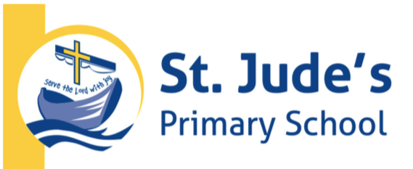

Enrolment Policy

Rationale
St Jude the Apostle Primary School is under the direction of and is a part of the Parish of St Jude the Apostle, Scoresby. It exists to support parents in the faith education of their children.

Catholic education is intrinsic to the mission of the Church. It is one means by which the Church fulfils its role in assisting people to discover and embrace the fullness of life in Christ.

The Australian bishops established Catholic schools in the 1860s as a key instrument of catechesis and sacramental preparation for Catholic children. Catholic schools continue to offer a broad, comprehensive curriculum imbued with an authentic Catholic understanding of Christ and his teaching, as well as a lived appreciation of membership of the Catholic Church.

The first priority of a Catholic school is to provide a Catholic education for Catholic children. This priority reflects the historical context of Catholic education in Australia, as well as confirming the participation of Catholic schools in the mission of the Church. As a result, formation and education in a Catholic school must be based on the principles of Catholic doctrine.

Catholic schools in the Archdiocese of Melbourne are primarily for Catholic children, so should strive for the highest possible level of Catholic enrolment. Catholic Education Melbourne and schools are expected to work together to achieve this goal.

To ensure that Catholic schools are accessible for all Catholic families, this policy promotes a consistent and transparent approach to establishing and implementing local school enrolment policies, and complies with all relevant legislation. To achieve this objective, schools are required to cooperate and collaborate to ensure fair and equitable access to Catholic schools for families.

This policy also supports the special relationship that continues to exist between the Catholic Church and the non-Catholic Eastern churches, based on a belief in the same sacraments and a close nexus in understanding about theology and sacraments.

Implementation
St Jude’s Enrolment Policy is based on the following principles
- Our school is founded on the person of Jesus Christ and enlivened by Gospel values in order to highlight the relevance of our faith to life and contemporary culture.
- Our school is committed to the development of the whole person and embedded within the community of believers and shares in the evangelising mission of the Church.
- Our school strives to cater for the needs of all students at each level and to meet individual needs over a wide range of learning abilities. These objectives must be equitably achieved within the constraints of the available teaching and material resources.
- Catholic families have a right to a Catholic education for their children whenever this is possible.
- Children from all families who are prepared to support Catholic ideals and principles may be considered eligible for enrolment. “Catholic families” are defined as families in which at least one parent is a Catholic or in which the children have been baptised Catholics.

Priority in enrolment is given in the following order, except in special circumstances:
- Children of Catholic families residing in the Parish
- Siblings of children currently attending St Jude the Apostle School
- Children of Catholic families residing in other parishes.
- Children of Orthodox or other Christian families residing in the Parish.
- Children of Orthodox or other Christian families residing in other Parishes.
- Children of families with other religious convictions.

In accordance with Victorian State Government guidelines, applications are accepted for children who are 5 years old on or before April 30th of the year they begin school.

Enrolment applications are to be accompanied by copies of Birth and Baptism certificates where applicable, and Immunisation Certificates. The Enrolment Committee under the direction of the Parish Priest considers all applications. Places are then offered according to the above criteria. After places have been accepted there is a process of orientation for both parents and children before school begins.

Discontinuing Enrolment
St. Jude the Apostle School has a Child Safety Code of Conduct and a Parent-School Code of Conduct that outlines behavioural expectations for parents, visitors and employees. Our Complaints Policy assists with dispute resolution, however, if the expectations outlined in relevant documents are breached this may result in grounds for termination.

Evaluation
This policy will be reviewed as part of the school’s four year review cycle or as required.

Date Reviewed | Feb 2019 | Reviewed by | Deputy Principal
Date Ratified | Mar 2019 | Ratified by | Principal

